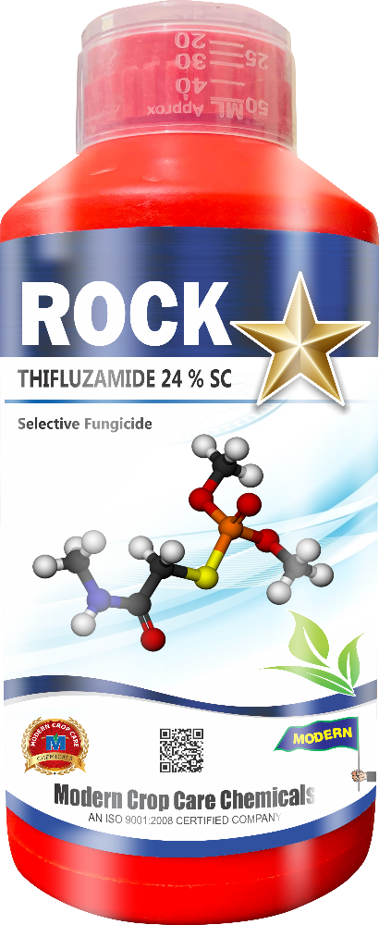
Product Name :- ROCKSTAR
Technical Name :- Thifluzamide 24% SC
Description :- Rockstar is a systemic fungicide with protective and curative action controls rice sheath blight caused by Rhizoctonia solani very effectively. Belongs to carboxanilide family. Rock Star is rapidly absorbed by foliage and is retained for longer period as a parental molecule. Rock Star imparts natural sheen to paddy crop. Rock Star is compatible with commonly used insecticides and fungicides. Rock Star is safe for beneficial insects.
Packing :- 500ml, 1ltr
Crops :- Paddy, Cotton.

Disease/Pests :- Neck Blast, Sheath Blast.

